Lab 3 – Echo & Reverberation

EE-3221/051 Digital Signal Processing

Dr. Marek Trawicki

By: Andrew Iliescu, Eduardo Diaz, & Than Win

16 January 2020

Introduction

The main objective of this lab consists of the use of MATLAB to apply signals to a system response. This will create echo and reverberation output signals. These output signals will be analyzed to better understand them and create more affective filters. These filters will be specifically designed to take out these effects.

Procedure

Materials:

* Laptop with MATLAB Software
* Earbuds or headphones

MATLAB Procedure:

* Load and listen to the original built-in discrete-time input signal x [ n ] called handel.
* Graph the handel signal as the discrete-time input signal x [ n ] and continuous-time input signal x ( t )
* Label all the appropriate quantities on the plots. Comment on the results.
* Solve the FIR system. (echo)
* Listen to the discrete-time output signal y [ n ].
* Graph the continuous-time input signal x ( t ) and continuous-time output signal y ( t ).
* Solve the FIR system (reverberation)
* Listen to the discrete-time output signal y [ n ]
* Graph the continuous time input signal x ( t ) and continuous-time output signal y ( t )
* Label all the appropriate quantities on the plots. Comment on the results.

Results

Using the load and sound commands from MATLAB, the sound clip, “handel” was played. This sound clip was a recording of a chorus playing *hallelujah*. The quality of the sound was clear and concise. To achieve this the file was loaded into a variable “S” and the “.” operator was used to obtain information such as the sample frequency. The discrete and continuous-time boundaries were set, and graphs were created for each.

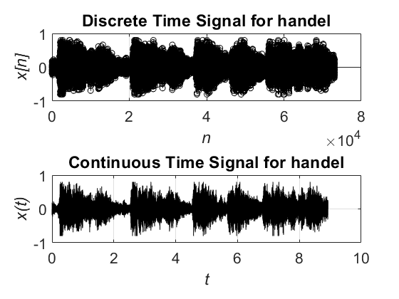

Figure 1: Original *handel* Signal

Figure 1 displays the pair of discrete and continuous-time signals for the original sound clip, “handel”. The length of the sound clip is just under 10 seconds. The discrete-time input signal is on top and shows the relationship between continuous amplitude and discrete-time. The graph on the bottom is the continuous-time input signal and shows the relationship between both continuous amplitude and continuous time.

The discrete input signal of “handel is then processed through a FIR system with the equation

(1)

The parameters for the equation consisted of β = 0.95 and D = fs / 2. The filter command, which filters the input data using the defined numerator and denominator coefficients b and a, was used to produce a continuous-amplitude versus continuous-time output for both the input and output signal as shown in figure 2. Concerning the sound of the modified clip, it sounded as if the sound was repeated at every unit of time it had. The closest example is as if the sound was bouncing off a wall and you hear it again.



Figure 2: Echo FIR input and output signals

Figure 2 shows the continuous-amplitude versus continuous-time input and output sound signals. The top signal is the input signal and the original sound. The bottom is the sound signal after going through the FIR system, (1). The length of the signal remained the same in the output as the input, however the amplitude of the output signal was changed. The amplitude of the output signal has more of a constant amplitude compared to the input signal. It is as if a copy of the original signal was taken and placed over itself and delayed.

The input signal was also put into the FIR system with the equation

(2)

The given radial distances were d1 = 17.2 m and d­­­2 = 34.3 m. The given speed of sound was

c = 343 m/s. The filter command, which filters the input data using the defined numerator and denominator coefficients b and a, was used to produce a continuous-amplitude versus continuous-time output for both the input and output signal as shown in figure 3. Concerning the sound of the modified clip, the sound compared to the original seemed extended. The effect was to a lower degree as seen in the Echo but still there.



Figure 3: Reverb FIR input and output signals

Figure 3 shows the continuous-amplitude versus continuous-time input and output sound signals. The top signal is the input signal and the original sound. The bottom is the sound signal after going through the FIR system, (2). The length of the signal remained the same in the output as the input, however the amplitude of the output signal was changed. In the signal at more times the amplitude is higher and fewer spikes than the original signal. This makes the output signal fuller with less breaks.

Conclusion

In conclusion, the laboratory was a success because MATLAB was used to listen, graph, and analyze the impact that a FIR system can have on a sound clip. Depending on the type of FIR system used to apply a filter to a signal, the effects are different. These advanced FIR systems and changing the initial conditions the effect can be changed. These types of systems are useful in the modification of audio, video and circuits involving digital signals.

Questions & Answers

1. Load and listen to the original built-in discrete-time input signal xSplat [ n ] called splat into the Command Window using the load and sound commands in Matlab. Graph the splat signal as the discrete-time input signal xSplat [ n ] (continuous-amplitude versus discrete-time) and continuous-time input signal xSplat ( t ) (continuous-amplitude versus continuous-time) using the stem and plot commands in a 2 x 1 plot. Label all the appropriate quantities on the plots. Comment on the results.

Using the load and sound commands from MATLAB, the sound clip of the *Splat* was played, producing the sound of a fall and a splat. The file was loaded onto a variable ‘S’, and the ‘.’ operator was used to access information such as the sample frequency. The discrete and continuous-time boundaries were set, and two graphs were created using the *stem* command and are shown in figure 4.



Figure 4: Original *Splat* signal

Figure 4 displays the resulting plots of the *Splat* signal, both in discrete and continuous time. Comparing the two plots, they are very similar however the discrete signal seems to have larger amplitudes.

1. Given the splat discrete-time input signal xSplat [ n ] , solve the FIR system (echo)

yecho[n] = xsplat[n] + βxSplat[n - D] (3)

with the parameter β = 0.95 and delay D = fs / 4 for the discrete-time output signal yecho [ n ] , where fs is the sampling frequency. Listen to the discrete-time output signal yecho [ n ] using the sound command. Graph the continuous-time input signal xsplat ( t ) (continuous-amplitude versus continuous-time) and continuous time output signal yecho ( t ) (continuous-amplitude versus continuous-time) using the plot command in a 2 x 1 plot. Label all the appropriate quantities on the plots. Comment on the results

Using the load and sound commands from MATLAB, the sound clip of the *Splat* was played. This time, however, the signal is filtered using the Echo FIR system. The discrete and continuous-time boundaries were set, and two graphs were created using the *stem* command and are shown in figure 5.



Figure 5: Echo FIR System input and output

Figure 5 shows the continuous time signal of the input and output of the filtered *Splat* signal. Comparing the input (original signal) to the output (filtered signal), the output signal has a delayed signal onto the original. This echo effect is more apparent in this signal and doesn’t blend into the rest of the signal. The delayed signal can easily be seen on the graph.

1. Given the splat discrete-time input echo signal xecho[n] = yecho , solve the IIR system (echo removal)

Yno echo [n] = -αyno echo[n- D]+xecho[n] (4)

with the parameter α = 0.95 and delay D = fs / 4 for the discrete-time output signal yno echo[n] , where fs is the sampling frequency. Listen to the discrete-time output signal yno echo[n] using the sound command. Graph the continuous-time input signal xsplat (t) (continuous-amplitude versus continuous-time), continuous-time output signal yno echo  (t) (continuous-amplitude versus continuous-time), and continuous-time error signal e(t) = xsplat (t) – yno echo(t) using the plot command in a 3 x 1 plot. Label all the appropriate quantities on the plots. Comment on the results

Using the filter commands from MATLAB, the sound clip of the *Splat* with the echo FIR system (Echo) was inputted to the IIR system (Echo Removal). The input and output of the IIR system is plotted in figure 6 along with the Error plot.





Figure 6: Continuous-Time Signal and Error graph of Echo Removal

Figure 6 shows the continuous time signal of the input and output of the filtered *Splat* signal. Comparing the input (original signal) to the output (filtered signal), The output of the IIR system removed the echo effect from the input signal. When comparing the original *Splat* sound, there is no indication that the sounds are different. This holds true when comparing the two plots and looking at the error plot.

Supplementary Materials

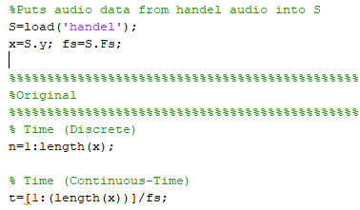

Used to generate and play the original handel audio file

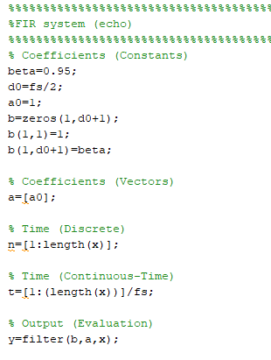

Calculations done to manipulate handel to have an echo

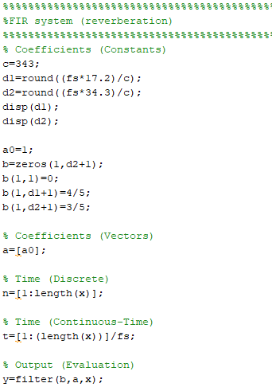

Calculations done to manipulate handel to reverberate

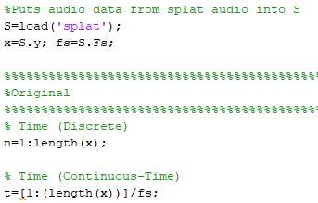

Used to generate and play the original splat audio file

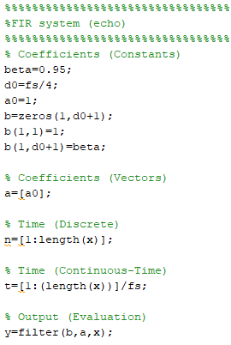

Calculations done to manipulate splat to have an echo

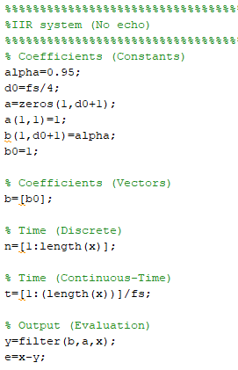

Calculations done in order to remove the echo from splat and calculate the continuous time error signal